6. House Number 6

Bania village, Blagoevgrad district, 36, 27 Str.

GPS N 41º53’07.4” and E 23º31’30.7”

The house is with 2 floors without basement.

The connection between the first and the second floor is with external stairs.

The floor area of the first floor is 80 m² and second is 80 m² approximately. If the walls are 2.8 m so the volume of the first floor is 224 m3 and of the second is 224 m3.

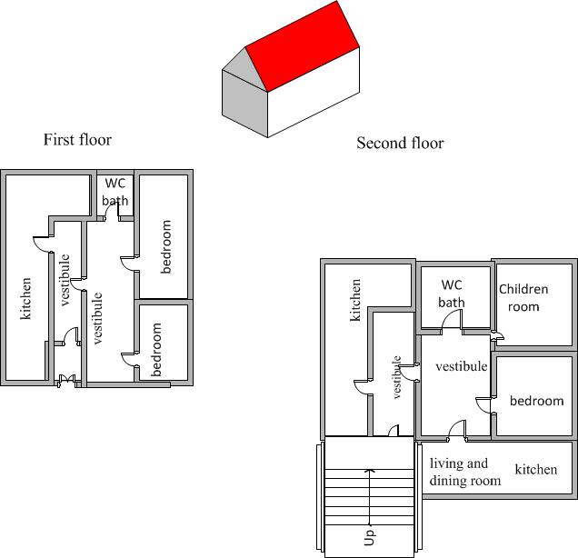

pair of CATS

relevant GTS